Lesson Plan 5: A Piece of Yourself
3DAA 4/17/18
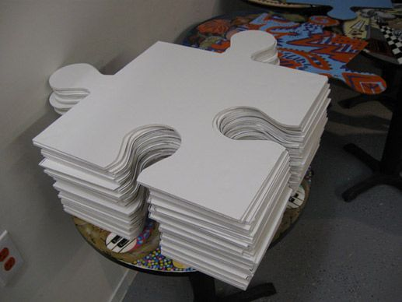

Lesson Idea and Relevance: What are you going to teach and why is this lesson of importance to your students? How is it relevant to students of this age and background? | A piece of yourself. We are going to make a collaborative project where students will get a giant puzzle piece and decorate it to represent themselves. This lesson will teach teamwork and collaboration which we haven't introduced yet and will be a good ending note for this class. It will also teach self-understanding because this puzzle piece will be a piece of themselves (or in other words who they are and what they like).

Essential Understanding (s): What are the “big ideas”? What specific understandings about them are desired? | Essential Question (s): What provocative questions will foster inquiry, understanding, and transfer of learning?
- Artists and designers can collaborate to make works of art and design.  - Artists and designers can explore their personal identity’s and that can be represented thought aesthetic decision making | - Why do artist tell about themselves thorough their art

Outcomes - Students will be able to...What key knowledge and skills will students acquire as a result of this unit? ...Art history and culture; expressive features and characteristics of art; art materials, tools, and techniques? What should they eventually be able to do as a result of such knowledge and skill? ...Compare and contrast artwork; analyze sketches?
Students will be able to
- Students will create meaningful pieces of art that reflect who they are
- Students will transfer personal meaning into their work.
- Students will reflect and comprehend on how their art all fits together but also is very different from one another

Student Reflective Activity: Through what authentic performance task(s) will students demonstrate the desired understandings? How will students reflect upon and self-assess their learning? | Assessment Instrument (s): By what criteria will “performances of understanding” be judged?
- Students will present their finished puzzle piece and explain the aesthetic choices they made in expressing their identity through this 3D medium.  - Students will discuss the challenges they faced in expressing their own identity as well as in working together as a group to create a finished art work. | - We will pre assess the students’ knowledge about identity and art before creating by discussing our previous lessons in which we used art to express our identities. We will ask questions like: “how did Leanne show us herself in her zebra safari vehicle sculpture?” “In what lesson did you feel your truly expressed your personality?”  - We will record different identities that the students come up with on the white board for them to refer back to while we do our brainstorming activity.  - We will be able to distinguish each students identity while putting the puzzle together.

Pre-assessment: How will you help the students know where the unit is going and what is expected? Help the teacher know where the students are coming from (prior knowledge, interests)?

We will use different ideation strategies, in which we will pre access while helping the students brainstorm ideas. We ask the students questions about how artists show their identity through their work and what is there identity. We will try to be as specific as possible while asking questions, in order for the students to come up with ideas. We will record their ideas on the board.

Motivation: How will you hook all students and hold their interest? | Ideation: How will you equip students, help them experience the key ideas, and explore the issues to generate ideas for their art work?
We plan on discussing puzzle pieces and how puzzles become one (just as we are individuals but as a class we are also one),  For example how we all like to create art, have fun and talk about each other etc.  “What connections can you make to the way puzzle pieces create a whole puzzle and the way each of us students adds up to a whole class?”  “What interests do you think we all share?”  We will have giant puzzle pieces cut out and laid in front of the students. We will write our essential questions on the board and then ask our students the questions as they answer them we will write the answers on the board. | We will have puzzle pieces available and at hand so students can see what we are going to do. This is a unit about individuality and community so we will have students answers questions about themselves, we will write down everyone's favorite colors, animals, experiences, culture etc. That way students will reflect what makes them, them. After the pieces are finished they will be pieced together to make one, like the community they are. Once they are put together the class will go around and talk about shared likes and interests. Then we will see if some of those are noticeable in the pieces they make.  We will also make sure to discuss shared likes, interests and events that connect us all in our little community.

Procedures: How is the lesson organized to maximize initial and sustained engagement as well as effective learning? Provide opportunities to rethink and revise their understandings and work? Allow students to evaluate their work and its implications? Include literacy and numeracy?

We will introduce (For example how we all like to create art, have fun and talk about each other etc. “What connections can you make to the way puzzle pieces create a whole puzzle and the way each of us students adds up to a whole class?” “What interests do you think we all share?”) the lesson to the students by discussing the previous lessons where we expressed our identities. This will help students start to think about how they are already capable of expressing their identities through art and set the stage for a project where they work together and express their personalities.

We will use ideation strategies to pre assess and motivate the students about our lesson. In which, we will ask the students questions like: “What is identity?” “How of artists show identity through making art?” “What is your identity?” “What is the first thing that comes to mind when you think of yourself?”

We will introduce the importance of collaboration and show examples of different collaborative artwork.

We will ask the students if they have ever participated in collaborative work.

We will show our examples of our own puzzle pieces and explain how our identities our shown through our puzzle pieces. (Why we choose certain colors, objects and why we arranged them the way we did) We will talk about how art can be used to express ideas about personal identity by asking students to reflect on their own likes and dislikes as well as how those interests compare to others in the group.

We will pass out our premade puzzle pieces and have all the materials ready at each table.
We will work with the students and aid them through their creation process.
When the students finish, we will connect the puzzle pieces together.
We will have the students talk about their identity.(likes, dislikes, important memories, “What connections can you make to the way puzzle pieces create a whole puzzle and the way each of us students adds up to a whole class?”
“What interests do you think we all share?”)

Take the last 15 minutes to clean.

